# Power Supply Concept in ETC

Introduction:

Our evaluation board E4, is supplied from two identical power-modules.

E4 board with 2 slots for power-modules:

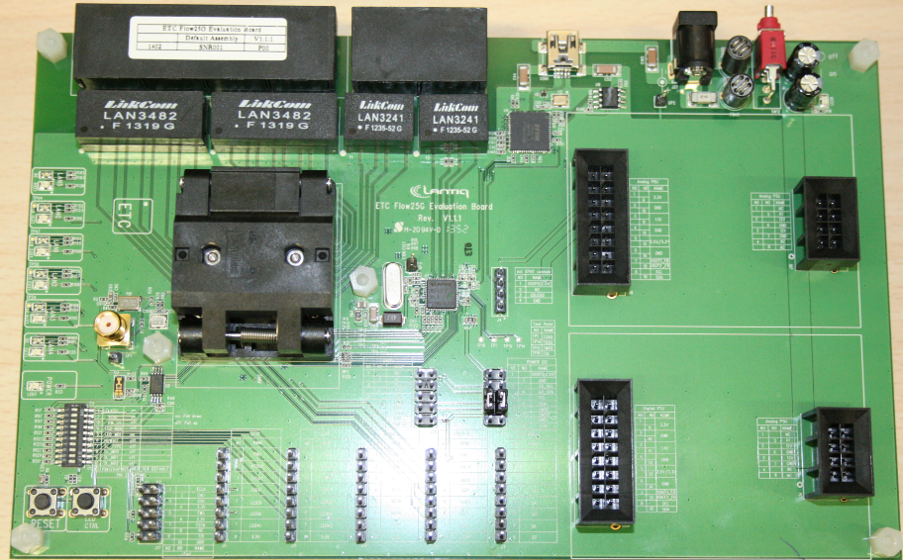

detail of an ETC power-module (top)

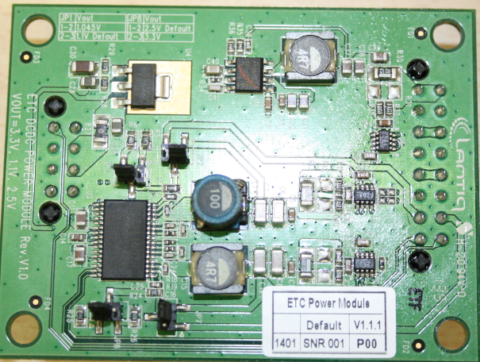

Each power module is providing 3 voltage outputs, V1, V2 and V3. Each output has voltage and current sensing implemented.

Voltage options available in ETC two power modules and their usage:

|  |  |  |  |
| --- | --- | --- | --- |
| supply output | default voltage | optional voltage* | optional voltage** |
| V1a - external GPHY supply | 2.5V | 3.3V | 0.7V-2.0V apx. (not useful) |
| V2a - internal GPHY VDDAL | 1.1V | 1.045V | 0.7V-2.0V apx. |
| V3a - internal GPHY VDDH | 3.3V | -- | -- |
| V1b - RGMII pad supply VDDR | 2.5V | 3.3V | 0.7V-2.0V apx. (not useful) |
| V2b - digital core supply | 1.1V | 1.045V | 0.7V-2.0V apx. |
| V3b - digital pad supply VDDP | 3.3V | -- | -- |
|  |  |  |  |
| *set by jumper |  |  |  |
| **set via I2C |  |  |  |

I²C concept of power modules plugged in ETC E4 board:

Each ETC power-module has 5 I²C peripherals connected to a common bus and both modules share the I²C bus once plugged to E4 board. Their I²C device addresses depend on the position of the power-module.

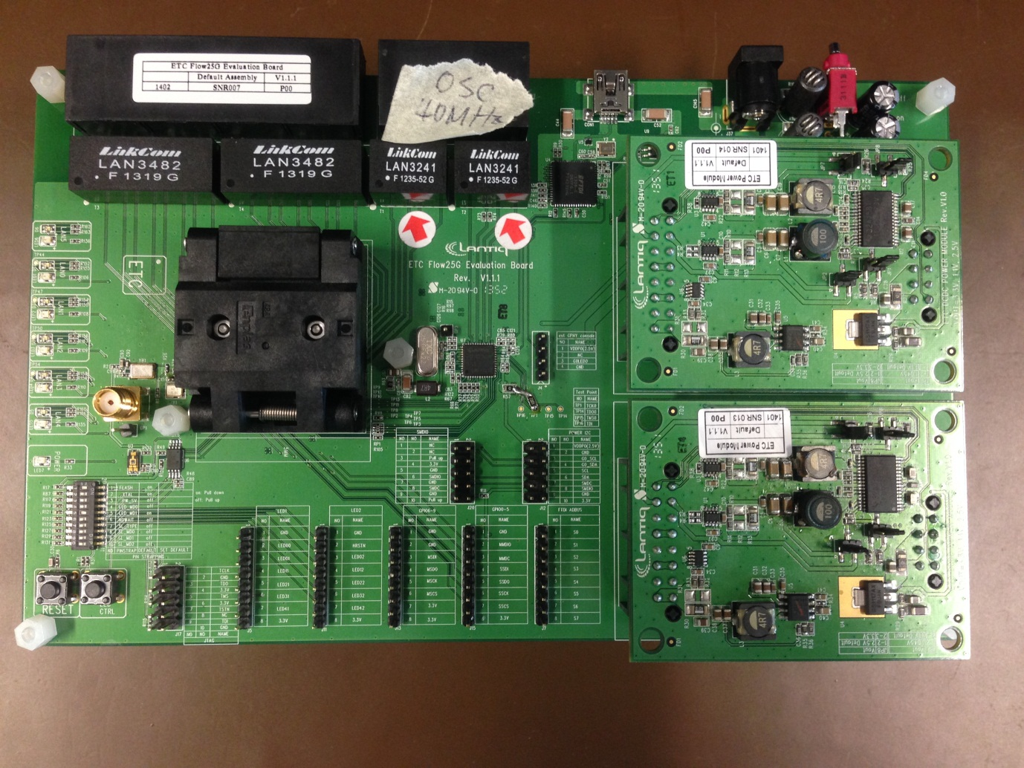

Power-Module A

Power-Module B

Power-Module A, in the upper slot, has address select A1 connected to ground. Power-Module B, in the lower slot, has address select A1 left open, with a 5k pull up resistor. Placing same module into slot 1 or slot 2, will automatically create appropriate A1 connection. (Address select A1 is header J1-pin-5).

I²C device address map of 10 devices of 2 ETC power-modules:

|  |  |  |  |  |  |
| --- | --- | --- | --- | --- | --- |
| **power module** | **device address 7-bit** | **locations/ registers** | **word  size** | **device** | **device description/purpose** |
| A | 0b1000000, 0x40 | 6 | 16 | power sensor V2a | current/voltage/power meter |
| A | 0b1000001, 0x41 | 6 | 16 | power sensor V1a | current/voltage/power meter |
| A | 0b1000011, 0x43 | 6 | 16 | power sensor V3a | current/voltage/power meter |
| B | 0b1000100, 0x44 | 6 | 16 | power sensor V2b | current/voltage/power meter |
| B | 0b1000101, 0x45 | 6 | 16 | power sensor V1b | current/voltage/power meter |
| B | 0b1000111, 0x47 | 6 | 16 | power sensor V3b | current/voltage/power meter |
|  |  |  |  |  |  |
| A | 0b1010000, 0x50 | 128 (256) | 8 | eeprom 1k/2k | calibration storage |
| B | 0b1010011, 0x53 | 128 (256) | 8 | eeprom 1k/2k | calibration storage |
|  |  |  |  |  |  |
| A | 0b1100000, 0x60 | 5 | 8 | dual regulator V2a | adjustment of 1.1V voltage |
| B | 0b1100001, 0x61 | 5 | 8 | dual regulator V2b | adjustment of 1.1V voltage |

summary of power sensor registers:

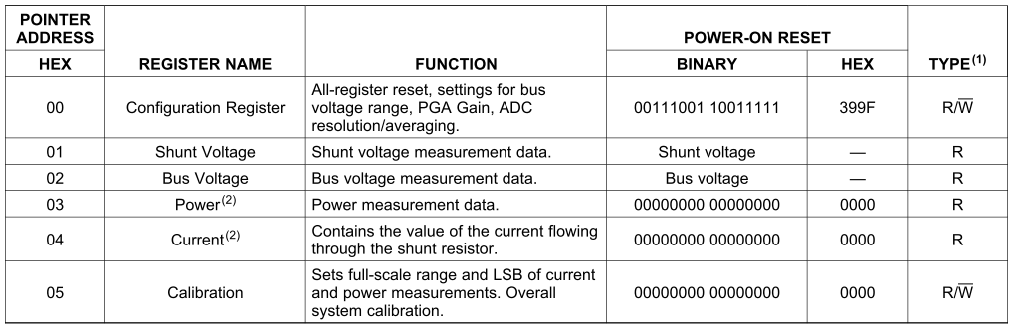

summary of regulator registers:

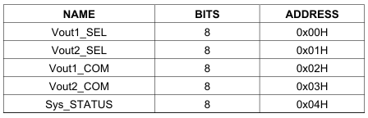

particularly useful register:

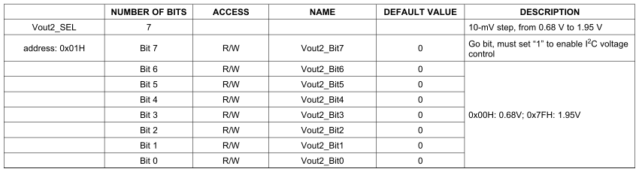

Suggested useful scripts to be developed:

get_power (V1/2/3a/b)

set_voltage (only for V2a and V2b)

calibrate

Calibration

All power supplies V1/2/3a/b are calibrated for voltage and current, furthermore, regulator setting of V2a/b is found/calibrated to correspond to the default setting, set by resistors. (this is required to prevent a voltage jerk when taking over voltage control.)

For adjusting V2a/b, please measure the voltage by the power sensor to guarantee desired voltage was achieved and do not rely on setting itself.

Current calibration:

Current is calibrated by finding the correct value of Calibration register (reg_addr=5 in power sensor). This is done by setting the power sensor Calibration register to its max value, which is I_cal_tmp=2**16-2. Assume known current value in mA is I_ref. Once temp current value (I_val_tmp) is found the new and final calibration value can be calculated as:

I_cal = int(I_cal_tmp*I_ref*10/I_val_tmp+1)

I = I_val/10 in mA

Voltage calibration:

Voltage is calibrated by finding a number that V_tmp must be multiplied to get voltage in mV. V_ref is in mV.

V_cal = int((2**16)*v_ref/V_tmp+0.5)

V = V_val*V_cal/2**16 in mV

Regulator calibration:

Finding a value of Vout2_SEL register of regulator is done by trying out values until measured voltage is same as default voltage (appx. 1.1V). This value is then used as starting point when changing the V2a/b voltage.

Calibration value storage format:

Values are stored in I²C flash in 16-bit mode (big endian)

|  |  |  |
| --- | --- | --- |
| addr | 16-bit value | comment |
| 0 | current cal value for V1x | I_cal |
| 1 | voltage cal value for V1x | V_cal |
| 2 | current cal value for V2x | I_cal |
| 3 | voltage cal value for V2x | V_cal |
| 4 | current cal value for V3x | I_cal |
| 5 | voltage cal value for V3x | V_cal |
| 6 | config value for V1/2/3x | config reg value for all power sensors |
| 7 | current cal value V2x | initial value of Vout2_SEL register |
| 8 | year of calibration | e.g. 0x2014 for 2014 |
| 9 | date of calibration | e.g. 0x0131 for January 31st |
| 10 | initials of calibrating person | 2xASCII characters, e.g. "AT" for Andy Teo |
| 11 | check-sum 16-bit | simple roll over sum of previous 11 entries |

Calibration board with known load:

